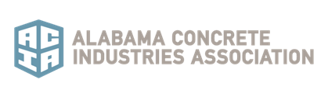

2020 Safety Awards

Nominations shall be made by submitting a detailed explanation for why the individual or company should be considered for the award. The explanation should focus on highlighting the criteria listed below. Submissions should include necessary supporting documents, a high-resolution electronic image of the nominee (if an individual), or a high-resolution company logo or any other relevant images. Please send submissions to rlindsay@alconcrete.org. Entries must be received February 21, 2020. For any questions, please contact the ACIA office at 334.265.0501.

Select your entry category: Corporate ____ Individual ____

Company or Individual’s Name Submitted for Award:

If individual name, company the person is employed by:

Person submitting the application:

Phone: __________________________ Email: __________________________________

Application should address all items that are applicable or write N/A if not applicable. Application can be completed electronically or filled completed on this form.

Give examples of how the company policy or individual has helped reduce accidents on the jobsite.

Give examples of how the company or individual has helped reduce accidents/incidents on the plant yard.

Give examples of how the company or individual has worked to identify, evaluate and control hazards.

Give examples of the company’s or individual’s development of safety conscious policies & procedures.

Give examples of the company’s or individual’s innovative techniques to promote safety.

Give examples of the company’s or individual’s establishment of a mentoring program for safety.

List any other notable safety initiatives established by the company or individual.

