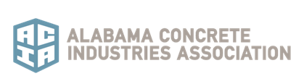

2020 Driver Lifetime Achievement Awards

This award recognizes and acknowledges the lifetime contribution that divers make to our industry. Each ACIA Producer Member Company is eligible to submit one nominee. Submissions are due by February 21, 2020 and should be sent to Rebecca Lindsay - rlindsay@alconcrete.org. For any questions contact the ACIA office at 334.265.0501.

Company Name

Driver Name:

Years of service to the concrete industry:

Miles/time driven since last chargeable accident:

Phone: __________________________ Email: __________________________________

Company Representative:

Title:

Questions regarding nominee. Please select YES or NO and provide details when noted.

Nominee actively employed as a ready mixed concrete driver for a minimum of 20 years? YES/NO
Did nominee have any violations, accidents or drug/alcohol convictions in the last 5 years? YES/NO
(if yes, provide explanation on separate sheet)

Has nominee’s MVR been verified in the last 30 days? YES/NO

Did nominee have any property damage claims within the last 5 years? YES/NO
(if yes, please provide separate explanation)

Does nominee have any “at fault” rejected/returned loads for the past 5 years? YES/NO

Does nominee promote on-the-job safety with a safety-focused attitude? YES/NO

Does nominee keep his/her truck clean? YES/NO

Additional items for submission

Please attach a statement from supervisor and/or company representative stating why nominee should receive award.

Please submit a list of personal awards, certificates, and/or honors received by nominee.

You may include up to 3 letters of recommendations and/or testimonies from customers, contractors or others.

Please send a digital picture of drive with his/her truck and up to 5 additional photos of the driver (to be used during presentation).

All supporting documents should be emailed along with the application to Rebecca Lindsay at rlindsay@alconcrete.org.

